Name ______________________________________
Homework Paper #3
Due ____________

Reading Comprehension
There are Five Steps to Success for any reading passages:
1. Read the title, author, and any headings.
2. Read the first two questions.
3. Read and interact with the selection.
4. Ask yourself, “What was the main idea and the author’s purpose?”
5. Answer the questions using process of elimination.
Read the passage and answer the questions that follow.
The Blarney Stone
by London Allen
¶Each year, thousands of tourists visit Blarney Castle in Blarney, Ireland. They come to see, and sometimes kiss, the Blarney Stone, located high in the castle’s basements. The three-story castle was built in 1446 by the king of Munster. The stone that exists today is thought to be half of the original Stone of Scone, which belonged to Scotland. Scottish kings were crowned over the stone because of its alleged mystic powers.
How the Blarney Stone earned these assumed powers is unclear. One legend says that an old woman cast a spell on the stone to reward a king for saving her from drowning. Kissing the stone gave the king “blarney,” which is the ability to speak convincingly.
The term blarney must have originated from the many unsuccessful promises of Cormac McCarthy, King of Munster, who promised to give his castle to the Queen of England. But he delayed doing so with soft words, which Queen Elizabeth I described as “blarney talk.” Other legends say that the definition came from another king who once lived in the castle; he had the ability to remain in the middle of an argument without taking sides.
Tourists who want to kiss the Blarney Stone do so with great difficulty: they have to lie on their backs and bend backward and down, holding iron bars for support.¶
1. What is the setting of the passage?
A. Scotland B. London C. Ireland D. Munster
2. Which of the following is the best synonym for “blarney”?
A. athleticism B. drivel C. quarrel D. kissing
3. Which of the following statements from the selection is an opinion?
A. The castle was three stories high.
B. Thousands of tourists visit Blarney Castle each year.
C. Scottish kings were crowned over the stone
D. Tourists who want to kiss the Blarney Stone do so with great difficulty.
4. Using context clues, draw a conclusion as to what the term “mystic” means. ________________________________________________________
______________________________________________________________

Classroom Connections
Write a genre from the bold word bank to complete each sentence:
Mystery Poetry Essay Biography Myth
1. A ________________ often involves the solution of a crime.
2. A ________________ often attempts to explain some natural phenomena and involves the actions of the gods.
3. Verse of rhythmic writing that creates an emotional response is called _______________.
4. A ________________ is a factual account of a real person’s life written by someone else.
5. An ________________ is a short composition that reflects the author’s point of view on a topic.
Writing and Grammar
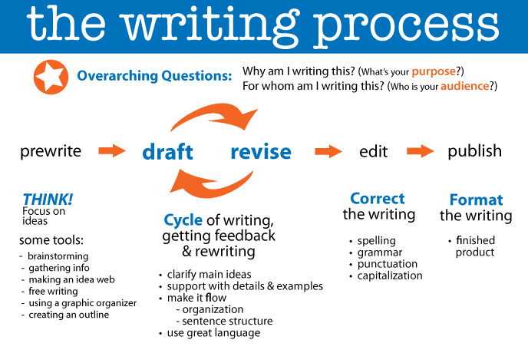

The five stages of the writing process are as follows:
1. Prewriting – this is where you would create a graphic organizer, brainstorming general ideas of your paper
2. Drafting – in this stage, you would write the general foundation of your paper; you do not pay attention to style, syntax, diction, or clear thoughts.
3. Revising – this is where YOU proofread your paper and make general corrections to vocabulary, sentence structure, punctuation, and insert any required elements.
4. Editing – step 4 requires a more focused eye as you reread your writing, looking more closely for any mistake, no matter how minor. You may use the assistance of peers, parents, or teachers. Always read your paper aloud to yourself.
5. Publishing – you are clear to rewrite – in your neatest penmanship – your final paper.

Answer True or False to the following questions about the writing process:
1. If your draft is neatly written, you are finished and your paper may be turned in. ___________
2. Generally, revising & editing are the longest stages in the writing process. __________
3. It is generally helpful to have other individuals read your writing and make suggestions. __________
4. You can only use this writing process in language arts class. _________

Cross-Curriculum & Miscellaneous
Science: Label the following properties as either Physical or Chemical
1. Blue color ____________ 2. Density ____________
3. Flammability __________ 4. Solubility __________
5. Supports combustion ________ 6. Sour taste __________
7. melting point ____________ 8. Hardness __________
9. boiling point ___________ 10. Odor ___________
Math: Answer the following questions and show steps:
1. (-4)⁻³ 2. (8)⁻² 3. (5)⁻⁴ 4. (-2)⁻⁵ 5. (3)⁻⁶

Social Studies: Finish the following statement: This week in social studies, I learned _______________________________________________________
_____________________________. Furthermore, I enjoyed _____________
______________________________________________________________
_____________________________________________________________ .

